Report of Regional Training Course on “The Application of New Mutagenesis Approaches in Crop Plants”

The IAEA Regional Training Course on “The Application of New Mutagenesis Approaches in Crop Plants” under the IAEA/RCA Project RAS5056, was organized by the International Atomic Energy Agency (IAEA) in cooperation with the Government of China through the Institute of Crop Science (ICS), Chinese Academy of Agricultural Sciences(CAAS), in Beijing, China, from 28 October to 1 November 2013. Altogether 29 participants from Bangladesh, India, Indonesia, Korea, Malaysia, Mongolia, Myanmar, Nepal, Pakistan, Philippines, Sri Lanka, Thailand, Vietnam and local organizations, respectively, attended the course. The main lecturers of this course were Dr. Luxiang Liu, Dr. Qinyao Shu, Dr. Long MAO, Dr Xiaofei Wang, Dr.Li Sui, Dr. Yuguang Xie, Dr. Guangpeng An, Dr Huijun Guo and Dr. Jiayu Gu from the local host country.
The program of the training course consisted of lectures, practical laboratory work and irradiation facility visit and field visit to create awareness and provide scientific and technical information on optimization and application of new mutagenesis techniques for crop plant improvement programmes.
The training course included: Plant mutation breeding-fundamentals and impact; Biological effects of different mutagens (γ rays, fast neutrons, protons, heavy ion beams and spaceflight, etc ); Theoretical introduction and technical demonstration of heavy ion beams irradiation; Theoretical introduction and technical demonstration of simulated cosmic rays irradiation; Experimental demonstration of biological effect of heavy ion beams compared with gamma rays; TILLING and proteomics approaches for crop mutants derived from heavy ion beams irradiation and space muatagenesis; Field and facility visit of heavy ion beams irradiation and simulated space mutagenesis; Discussions on specific breeding problems and the most suitable mutagenesis approach for a target crop.
Technique visit to the nuclear irradiation facilities for gamma rays, fast neutron, accelerator ion beams and proton at the China Nuclear Research Institute and Peking University, accelerator based multi-heavy ion beam facility at the Institute of High Energy Physics, Chinese Academy of Science were properly arranged during the course, which should be the first time for the trainees under the Agency’s training courses by far. All the participants also visited the National Key Facility for Crop Gene Resources and Genetic Improvement, National gene bank.
A CD for collections of the lecturers’ presentations and some key literatures for further reading were distributed to all the participants. 93.1%(rank 5 and 4) of the participants gave excellent or good assessment in the questionnaire (as attachment of consolidated ).

Press:
http://www.caas.cn/ysxw/xzhd/77974.shtml
http://icscaas.com.cn/Html/2013_11_05/17968_18131_2013_11_05_88396.html

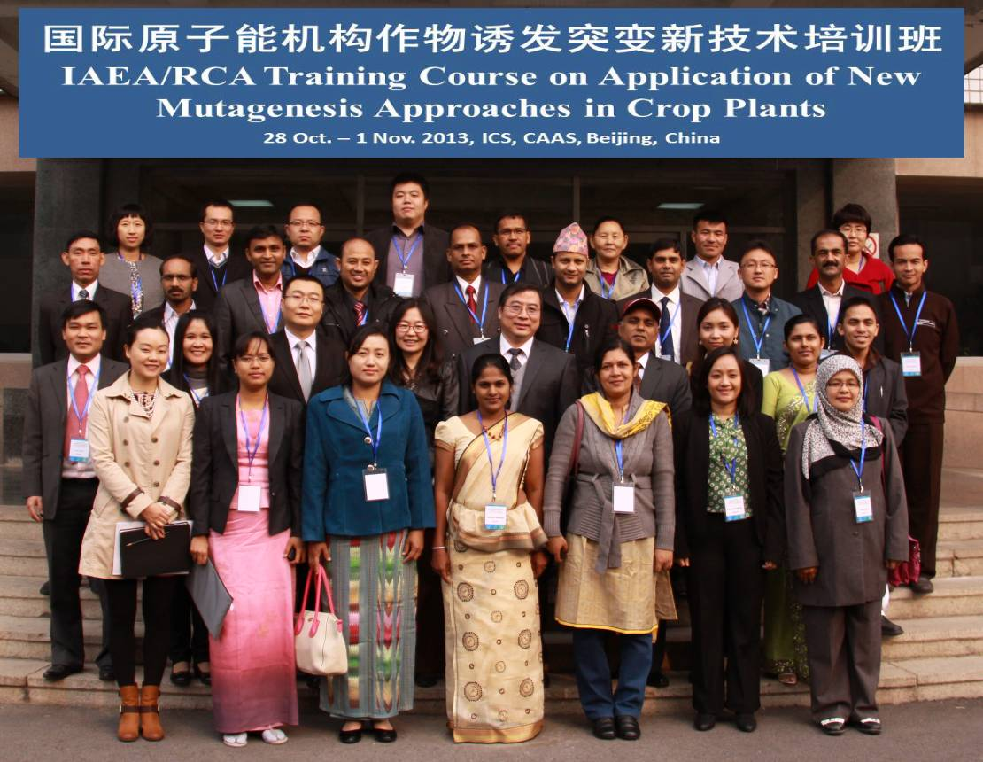
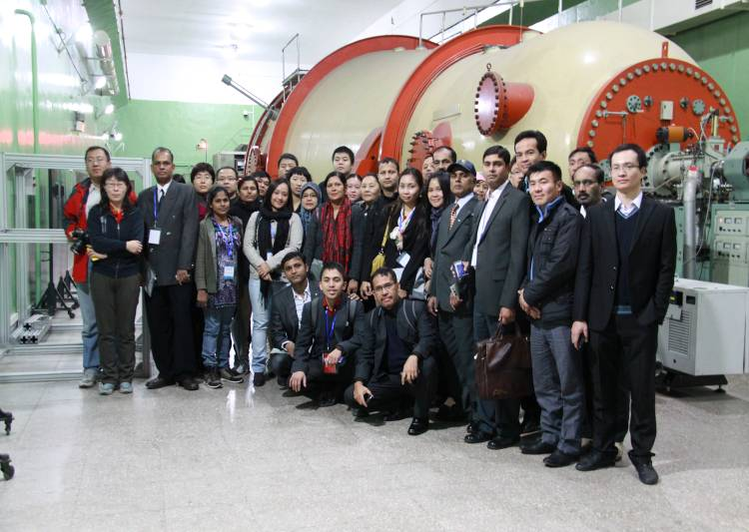

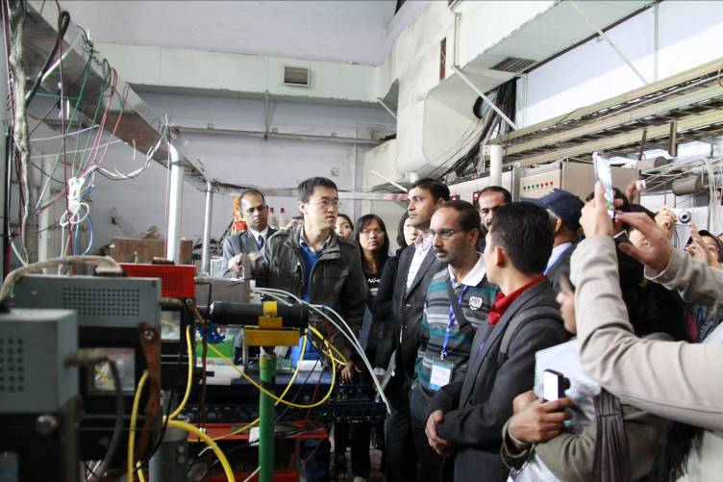
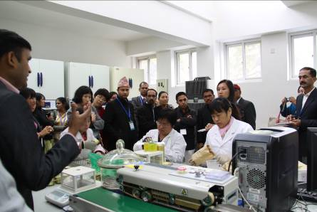

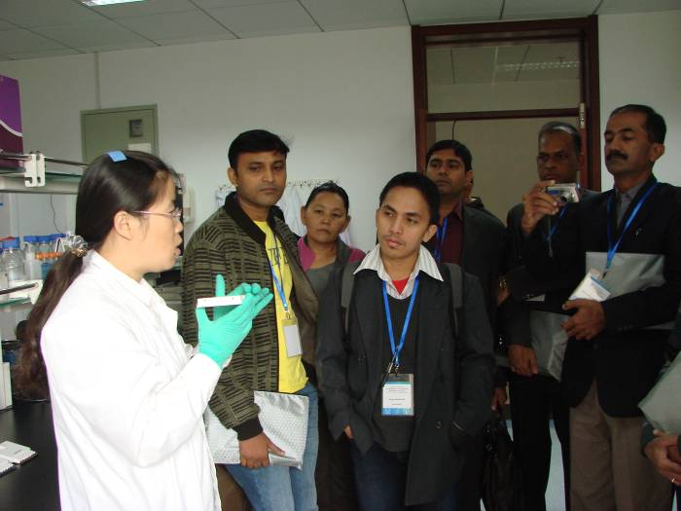
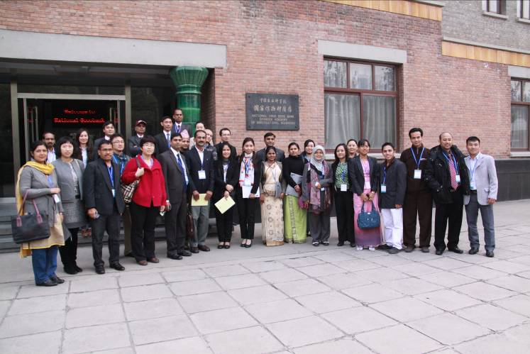

Liu Luxiang
Course Director, RTC-RAS5056-003
Institute of Crop Science (ICS),Chinese Academy of Agricultural Sciences (CAAS)
12 Zhongguancun South St, Beijing 100081, China
Tel: 86-10-62122719 Fax: 86-10-82105811
Email: liuluxiang@caas.cn

